
Instructions for writing a donor appreciation letter
APPENDIX C: DONOR APPRECIATION LETTER

When writing a donor appreciation letter:
- Insert the donor’s name, and address at the top of the page.
- Insert the donor’s name after the word “Dear”.
- Use the following donation amounts and tangible descriptions.

Donation Amount | Tangible description
$10 | will provide a Peruvian Promise scholar with 2 weeks of daily English classes.
$15 | will help purchase an English workbook for a Peruvian Promise scholar for 1 year.
$20 | will provide an entire month of daily English classes for a Peruvian Promise scholar.
$25 | will provide a Peruvian Promise scholar with a school backpack.
$30 | will help purchase school supplies for a Peruvian Promise scholar for an entire semester.
$50 | will provide 25 Peruvian Promise scholars with a 2-hour workshop from a professional mentor.
$75 | will pay for 3 months of English classes and an English workbook for an entire year.
$100 | will provide a Peruvian Promise scholar with a college uniform for an entire year.
$200 | will provide a Peruvian Promise scholar with 10 months of English Classes.  OR  will provide a Peruvian Promise scholar with her college books and school supplies for an entire year and tuition for one extra-curricular class.
$500 | will provide a Peruvian Promise scholar with books, school supplies, a uniform and transportation for an entire year.
$1,000 | will provide a Peruvian Promise scholar with college tuition and registration fees for one semester
$2,500 | will provide a Peruvian Promise scholar with college tuition, registration fees, books, supplies, a uniform and transportation for an entire year.  OR  will provide a Peruvian Promise scholar with room and board for an entire year.
$5,000 | will provide a Peruvian Promise scholar with a college education including room and board for an entire year.
$10,000 | will provide a Peruvian Promise scholar with a college education including room and board for two years.

- Sign the letter. A sample letter is shown on the next page.

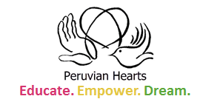
Mr. Brian Jones
345 Apple Way
Logan, UT 84555

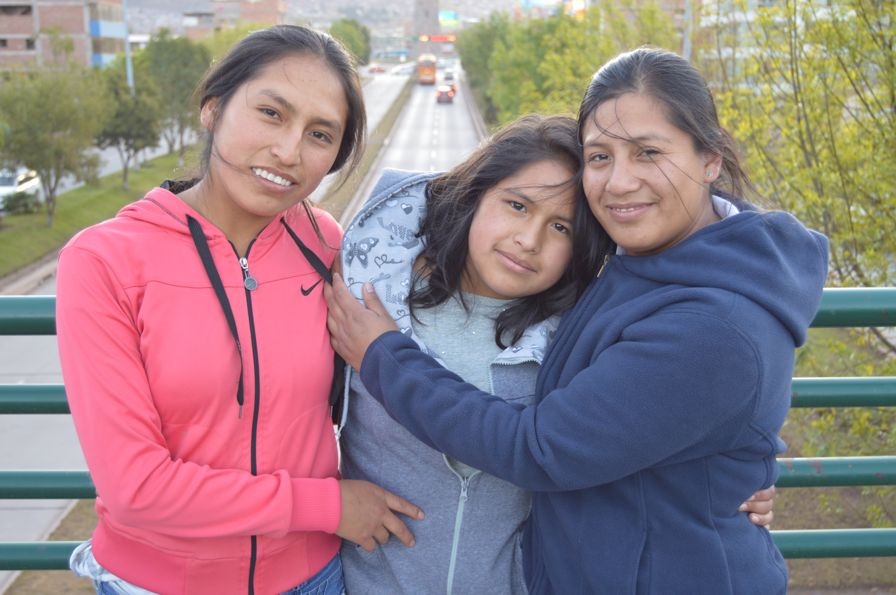
Dear Mr. Jones,
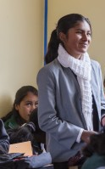
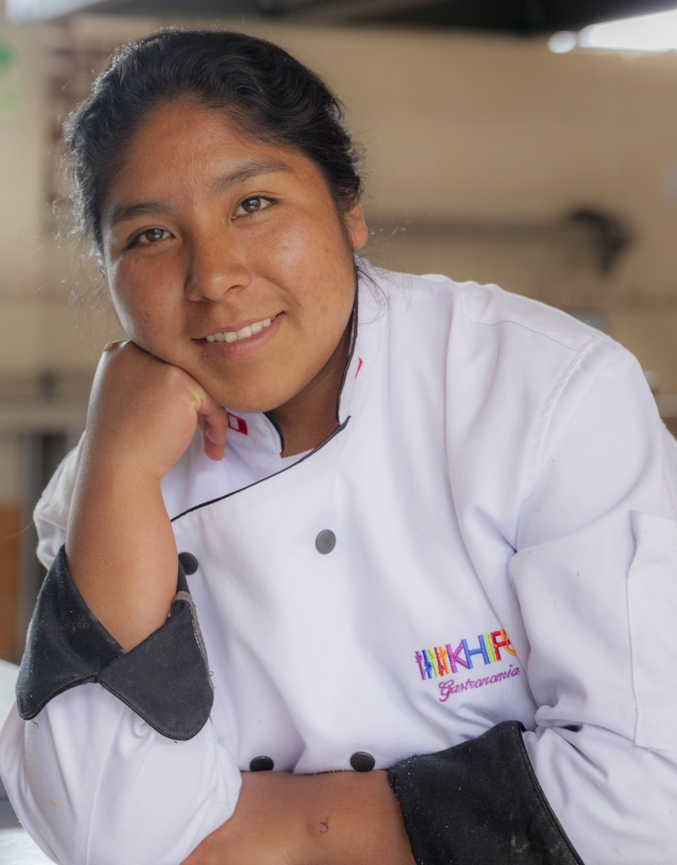
THANK YOU for your generous donation of $500 and welcome to the

Peruvian Hearts family. Your willingness to help these young scholars is making a huge difference in their lives. Because of your donation, we are able to provide one scholar with books, school supplies, a uniform and transportation for the entire year! You are making a profound difference by changing Peru one girl at a time.
I am always available to talk with you and answer any questions regarding the Peruvian Hearts program. Don’t hesitate to call me at (303) 526-2756 or email me at peruvianhearts@gmail.com.

Sincerely,
Danny Dodson, CEO, Peruvian Hearts
Our Promise: Peruvian Hearts works to end poverty and gender inequality by educating young women and creating community leaders in Peru—one girl at a time. Peruvian-born Ana Dodson developed this nonprofit organization to enable young women to embrace education, believe in their own power, and dream of a life beyond the conditions into which they were born.on, Pesruv

