The Meyer Foundation’s 2013 “Stories Worth Telling report identified five building blocks of an effective story for nonprofits. Peruvian Heart’s “girl power” message can be applied to each building block as follows:

Effective Characters
Make each PH girl a character
Make Ana a character (“could have been her”)
Make the girls their own heroes – they are “empowered”
Focus the stories not on the physical donation (money, books, tech) but on donors giving the girls dignity, their dreams, power to do more
Establish a commonality between the PH girls and the audience so donors relate and feel transported into their world

Trajectory
Chronicle an experience or a journey

Authenticity
Use first-person narratives told by the PH girls
Show rather than tell the stories

Action-Oriented Emotions
Set a goal for the story
Donate, raise awareness, or engage
Create a call-to-action
Place a donation path in the story (donation goal)
Make the story easily shareable (awareness goal)
Provide the opportunity to sign up for newsletters or follow social channels (engagement goal)

A Hook
What is the reason to care?
What’s at stake?

5 steps to Effective
Storytelling

E-Newsletter Instructions
APPENDIX B: NEWSLETTER

Invite donors into the PH family by sharing individual and personalized messages from PH girls about their experiences in the program. Impactful stories create personal connections with the power to strengthen donor relationships and keep supporters aware of PH’s many successes.

The stories/content for the e-newsletter should first be posted on a blog page within PH’s website. The blog space provides a digital home for the stories so once they are linked in the e-newsletter the story is clickable, shareable, and leads to more PH content within the PH website.

- Email the newsletter once a month
- Use a template for consistency and ease
- Plan story content ahead of time
- Ask for writing help from the scholars and PH volunteers

E-newsletter Template
- Top story with photo
  - Story is any length. Approximately 80 – 100 words are displayed. Include a hyperlinked prompt to read the full story on the blog
  - Written by Danny, Ana, or another PH admin
  - Topic is an overall PH program update, significant milestone, general news, or press release
- Scholar story with photo
  - Story is 80 – 100 words in length with a hyperlink to girl’s profile on the PH site
  - Written in first-person by a PH scholar girl
  - Topic is a personal account of an accomplishment or recent experience in the program
- Miscellaneous story with photo
  - Story is 50 – 60 words in length, or longer when hyperlinked to the blog to read the full length
  - Topic can be a re-share of a social channel post, Dodson family news, volunteer experience etc.
- Side-bar (green box) content
  - Approximately 50 words in length
  - Statistics, fast facts, fun facts, infographics and FAQ’s about PH agendas i.e. poverty, child bride, why girls, gender equality, leadership, education, Peru
- Final call-to-action
  - Brief closing remark from Danny. If it’s a donation message – provide a donation hyperlink. If it’s an awareness goal – hyperlink to a relevant PH or partner page
- Promotional text box
  - Single sentence promotion of upcoming media coverage, an event or volunteer opportunity
- Boilerplate
- Mandatory e-newsletter subscription information


Peruvian Hearts
December 20, 2015

Congratulations to Our First Graduates!
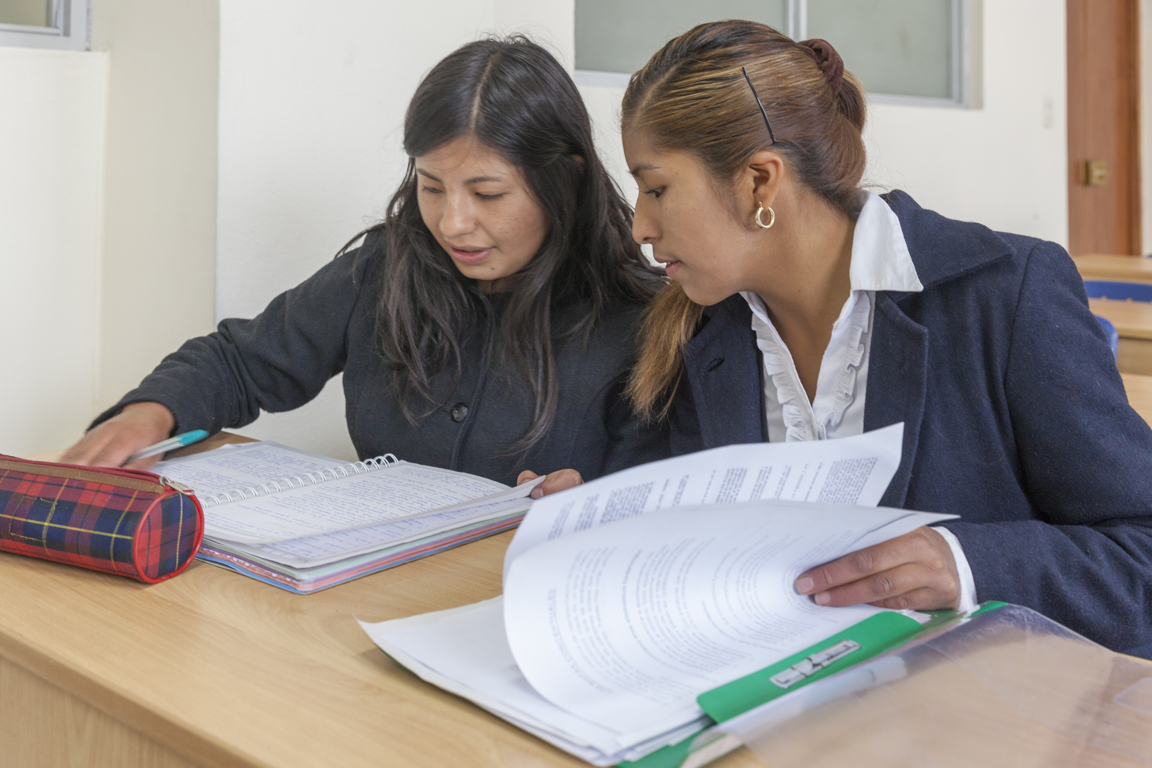
Restaurateur, author, mining executive, and finance mogul. The big dreams of Peruvian Hearts’ first college graduates are now very much in the realm of possibility with degrees in their hands.
The first four young women to complete their college educations are receiving degrees in culinary arts, accounting, and chemical engineering. Once timid, shy girls – Katy, Nelly, Epifania, and Rosa are confidently pursuing their dream jobs and inspiring others with the leadership skills gained in the Peruvian Hearts scholar program. The women will stay close to the Peruvian Hearts family and return to mentor the girls following in their footsteps…READ MORE

CHILDBRIDE OR CHEF
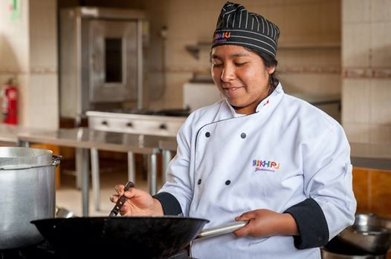
Have you heard about the chocho or tarwi bean? I’ve been learning about its high protein and fat content that make the bean such a nutritional ingredient for soups and sauces. I’m studying culinary arts at Khipu University. If it wasn’t for Peruvian Hearts I might have been married at 14 or early. Instead of having children while I was still a child myself I am now surrounded by other girls just like me. When I lived in the hogar I was shy and timid. Now I can’t wait to share my new knowledge with others because I now see that I am an example for my siblings. My dream is to own my own restaurant and write cook books.
Nelly, Peruvian Hearts Scholar
GLOBAL DOVE GIRLS

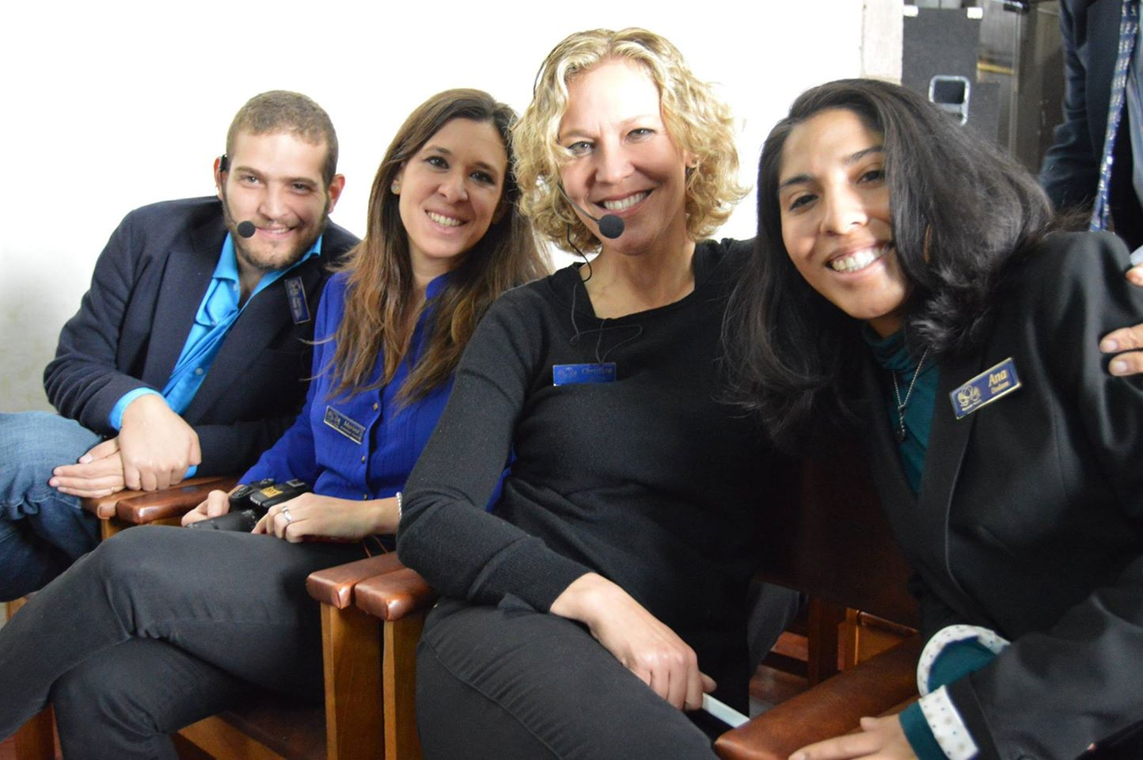
THE ANATOMY OF A DONATION
For every dollar donated in support of Peruvian Hearts:
- 45 cents goes to tuition, books, and supplies of currently enrolled young women.
- 32 cents goes to room and board for the girls.
- 10 cents goes to funding future scholarships.
- 22 cents for operational costs.

We are thrilled about our partnership with Christina Berton, Marina Armendares Fontaine, and Santiago Trabolsi, of the Amara Foundation in Mexico City. This amazing team works directly with Dove's Global Girls' Self-Esteem Project and has teamed up with Peruvian Hearts to support the scholars of ‪‎Peruvian Promise‬. Learn more about the Amara workshops with our scholars.‬‬‬‬

MORE THAN BOOKS
At Peruvian Hearts we make every penny count toward educating our young women scholars. We’ve seen education transform minds, lives, and futures. Your support is so much more than a gift of books or technology – it’s giving a girl confidence and the power to dream. Please visit our donation site to consider one of the many ways you can empower girls.

THANK YOU,

DANNY DODSON, EXECUTIVE DIRECTOR
///

Peruvian Hearts, 24918 Genesee Trail Road, Golden, CO 80401, USA Unsubscribe | Change Subscriber Options

